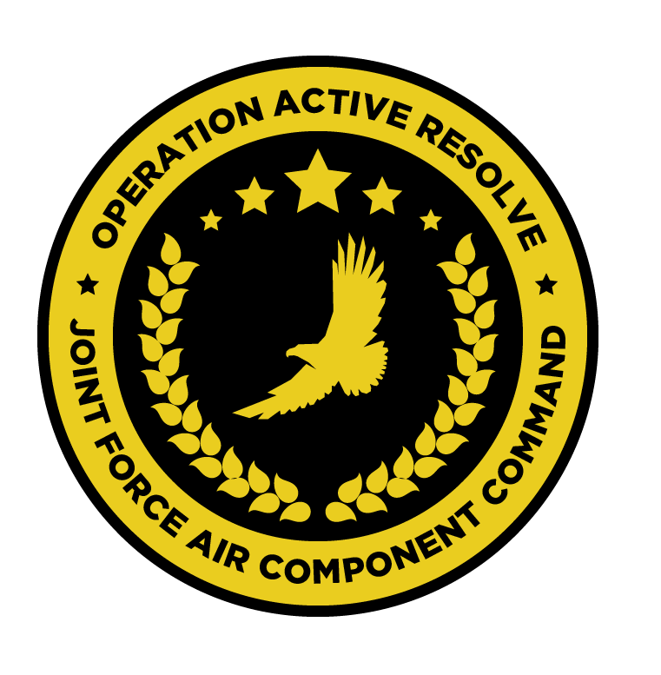

JFACC AIR OPERATIONS DIRECTIVE

OPERATION ACTIVE RESOLVE

D+1

# 1. SITUATION

## a. JFC guidance (verbatim).

See [CJTF Operations Order](https://132nd-vwing.github.io/OPAR-Brief/ORDERS/OPAR%20CJTF82%20OPERATION%20ORDER.pdf)

## b. Enemy situation.

See [VIS INTSUM D+1](https://132nd-vwing.github.io/OPAR-Brief/INTELLIGENCE/INTSUM/D1/VIS%20INTSUM%20D1%20Ground.pdf)

## c. Friendly situation (by joint force component).

See [CJTF Operations Order](https://132nd-vwing.github.io/OPAR-Brief/ORDERS/OPAR%20CJTF82%20OPERATION%20ORDER.pdf) and [LCC III Corps Conops](https://132nd-vwing.github.io/OPAR-Brief/ORDERS/OPAR%20LCC%20III%20CORPS%20CONCEPT%20OF%20OPERATIONS%20PHASE%201.pdf) and [LCC IV Corps Conops](https://132nd-vwing.github.io/OPAR-Brief/ORDERS/OPAR%20LCC%20IV%20CORPS%20CONCEPT%20OF%20OPERATIONS%20PHASE%201.pdf)

# 2. MISSION - The JFACC’s mission statement (verbatim).

JFACC will establish air superiority in the area of operations and defeat Syrian offensive capability in support of CJTF-82 offensive operations to neutralize Syrian offensive capability to conduct offensives in the region.

# 3. EXECUTION – AIR OPERATIONS

|  |  |
| --- | --- |
| **JFACC’s Intent**   1. **Purpose** 2. **End State** | JFACC’s intent is to provide airborne assets in order to achieve air superiority in Turkish and Isreali airspace, such that Syrian aggression into this airspace is prevented, ensuring the protection of ground forces from Syrian air attacks.  This first paragraph does not add any more than what is already stated in the JAOP? If it is already in the JAOP, it can be deleted. For the execution, only include thing that is new or valid for this (to keep things short and precise).  Further, it is intended that support be provided to friendly ground forces through the availability of air-to-ground strike aircraft, performing a variety of missions throughout the AO.  It is intended that such operations be complemented by a small number of Air Interdiction operations in order to meet strategic objectives as outlined by CJTF82.  The purpose of such operations is three-fold:   * To shape the AO . * To deny Syrian air forces the use of the air in order to aggress against friendly ground forces. * To provide direct support to friendly ground forces by attempting to attrit enemy ground forces.   The desired end state of these operations is one in which Syrian forces have been expelled from Turkey and Isreal, with respect to both ground and air forces.  This purpose and endstate is again a little mix about what is relevant here for D+1 and what is the overall purpose and endstate for the phase in JAOP. I would suggest to here only put what you want to achieve this ATO day (event), as the overall big picture is (should be) covered in the JAOP  A intent for a AOD period can be something specific for example like this:  Intention is to set conditions for attacks at Syrian airbases on D+3 by neutralizing IADS in sector XXX.  Excess sorties will be used to support LCC  This gives guidance to AOC when he creates the taskings as he then can try to achieve what your intention is , and take the allocation plus intention and create tasks |
| **Execution** What to do, when. – Any detailed instructions if needed | In the execution of these missions, the AO is divided into two sectors – Sector NORTH and Sector SOUTH. These sectors are visible in the Airspace Control Plan ([ACP](https://132nd-vwing.github.io/OPAR-Brief/MISSION%20INFORMATION/AirspaceControlPlan.cf)).  Good, gives clear instruction how to use the battlespace  Operations are to be conducted in both Sectors NORTH and SOUTH, in addition to AO operations in support of the destruction of targets from the JPTL.  This can indicate that JPTL targets lies outside NORTH and SOUTH sectors. All JPTL targets lies in either NORTH or SOUTH sector, so this could be deleted as it do not add any value?  Operations are to be supported by friend AWACS and Tanker support  This is a given, and can be deleted. Only include if you have any specific guidance for AWACS and tanker support for this event. Also see acceptable level of risk further down |
| **Focus of effort by objective** | Three areas of focus are addressed in this AOD:  Three areas are addressed, but then only sector NORTH and SOUTH is coming up here. (Assume it is because you also think about the AI strikes)  **Sector NORTH**  In this sector, the majority of effort should be directed towards LCC IV Corps Objective BRAVO and the attrition of HQ assets in and around HATAY AIRFIELD and the area surrounding HATAY city.  LCC Corps objectives are key terrain primarily that ground forces need to control and dominate. So the land objectives are not enemy unit/formation centric, although they of course will defeat any enemy that challenges their ability to take these areas. Attrition of HQ assets in and around HATAY airfield is a good description I think. But remember we are still in the shaping phase, so focus can be on setting conditions : by going after air defense (will facilitate more air operations later), HQs, rocket artillery, artillery units as the primary targets in the Corps and Divisions in the area  Some focus should be directed towards LCC IV CORPS Objective ALPHA and the attrition of enemy ground forces, prioritising air defence assets, followed by the division of MBTs therein.  Same as above, is it not Objective ALPHA that is important, but rather the enemys 10th Armor division. So the task can be related to the 10th armor division  **Sector SOUTH**  Equal effort should be directed towards the attrition of LCC III Corps Objectives ALPHA and BRAVO.  Same as above |
| **Allocation of sorties** (in percent) - CAS, AR, AI,DCA, OCA (SEAD is part of OCA) | **Sector NORTH – 40% Total**  50% - AI against LCC IV Corps Objective BRAVO  30% - AR against LCC IV Corps Objective ALPHA  20% - DCA in support of friendly forces  **Sector SOUTH – 40% Total**  40% - AR against LCC III Corps Objective ALPHA  40% - AR against LCC III Corps Objective BRAVO  20% - Joint DCA/SEAD operations in support of the sector  **STRIKE – 20% Total**  70% - AI against JTPL targets  30% - Escort of AI flights, should resources permit  This was the most challenging when I was creating the taskings. If possible it would make it easier if you gave the allocation of sorties , and it was not tied to a sector:  So:  30 % DCA  30% OCA  20% AI (that is against targets on the JPTL not relevant for the air battle. If a tgt is on the JPTL that supports the air battle, it will be attacked as OCA)  20% AR  And after that you can give a priority to the sector: Priority 1 NORTH, priority 2: SOUTH  That way you influence what kind of sorties are being flown, and give the priority of area, but also do not go so far down in the details that you are creating the taskings, and by this create some flexibility for the AOC to do their job to meet your intent for the AOD period.  **LOGISTICS**  100% of logistical operations should be directed towards the deployment of air defence assets in friendly airspace. |
| **Acceptable level of risk**. (including for AWACS and tankers: forward or rear) | Tolerance of risk should be minimal in the execution of these missions – ground forces are currently not engaged in conflict and there should be no desire to unnecessarily persecute enemy forces in the execution of these missions.  Acceptable Risk Levels are stated in the SPINS (Default is medium). So if there is guidance that need to be given that is different from the standard given there, then it should be stated here.  For example:  For OCA missions we accept a HIGH risk level.  For AWACS and Tankers we accept a LOW risk level |
| **Collateral damage and civilian casualty guidance** | Every attempt should be taken to minimise collateral damage in the execution of these missions. Civilian casualties should be avoided at all costs.  In war, civilian casualties is expected, if it should be avoided at all cost, it will likely make it very hard to conduct operations. First sentence is good though as everyone should try to minimize civilian casualties and act in accordance with the Law Of Armed Conflict (LOAC: <https://www.doctrine.af.mil/Portals/61/documents/Annex_3-60/3-60-D33-Target-LOAC.pdf> )  Suspected civilian casualties should be reported through the C2 network as soon as is practicable. |
| **TST guidance** | Should opportunities present, items from the TST matrix should be prosecuted. The outcome should be reported to the relevant C2 agency.  Will add this to SPINS, so only things needed is if you have specific guidance, else than what is given in the TST matrix. |
| **Intelligence, Surveillance, Reconnaissance (ISR)** – If any effort should be done to support VIS with ISR to answer information gaps from VIS. | All notifications of enemy air defence assets – ground- and air-based – must be reported as soon as is practicable. Reports should, where possible, include the observing aircraft’s currently position, a relative bearing to the threat and the type of threat.  Good. Not sure how much it was executed, but we are on a good way of getting it done.  No specific ISR tasking are planned for this mission.  That is ok, but also consider that we are early, so getting intelligence is one of the most important things for us right now, to set the conditions for future strikes and make it possible to execute a good air campaign |
| **Other issues** | N/A |
| **Direction and Guidance** | Aircrews must remain clear of Jordanian airspace at all times. Munitions must not be expended which may encroach on Jordanian airspace.  Good |

# 4. ADMINISTRATION AND LOGISTICS

There are no known administrative or logistical considerations for these missions.

Can just be NSTR or N/A or simply refer to JAOP when you do not have any guidance here

# 5. COMMAND AND CONTROL

There are no known, specific C2 considerations for these missions. Refer to the Command, Control and Communications section of the JAOP.

Can just be NSTR or N/A or simply refer to JAOP when you do not have any guidance here